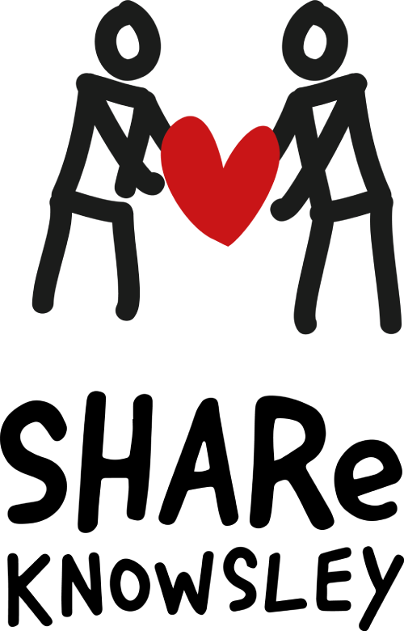
Support and Help for Asylum seekers and Refugees

Gift Aid Declaration – multiple donations
I want to Gift Aid my donation of £ ______________ and any donations I make in the future or have made in the past 4 years to SHARe Knowsley

Boost your donation by 25p of Gift Aid for every £1 you donate
Gift Aid is reclaimed by SHARe Knowsley from the tax you pay for the current tax year. Your address is needed to identify you as a current UK taxpayer.
By completing this form you confirm:
I am a UK taxpayer and understand that if I pay less Income Tax and/or Capital Gains Tax than the amount of Gift Aid claimed on all my donations in that tax year it is my responsibility to pay any difference.

Please complete in capitals
Date:
Title | Initials* |  | Forename(s) | Surname*
Address* (House Number and first line of address at least)
Post Code* |  | Signature (Optional)
*Please note that the details marked with * are mandatory.
You can either provide initial or forename or both, but you should AT LEAST provide one of the two.
Please notify SHARe Knowsley if you:
- Want to cancel this declaration
- Change your name or home address
- No longer pay sufficient tax on your income and/or Capital gains.
If you pay Income Tax at a higher or additional rate and want to receive the additional tax relief due to you, you must include all your Gift Aid donations on your Self Assessment tax return or ask HMRC to adjust your tax code.

SHARe Knowsley is registered in England and Wales as a charity (no. 1204302), at: The Old School House, St. John’s Road, Huyton, Liverpool, L36 0UX. Website: https://shareknowsley.org.uk/ email: admin@shareknowsley.org.uk

